**Isaac Asimov & Asimovian Robots**

Asimov is considered one of the “Big Three” science fiction writers of all time, along with Robert A. Heinlein and Arthur C. Clarke. He is responsible for bringing science fiction into mainstream literature and blending real science with fictional, futuristic ideas that remain a foundation of almost all popular Sci-Fi & Fantasy writing today.

His most lasting legacy, however, is the concept of “The Three Laws of Robotics” that has become the framework for all robot/human interaction in literature and movies.

***Thought to ponder: If our new level of technology has reached robotic levels (Alexa, Siri, GPS, Roomba, etc.), are these rules being followed in real life?***

**Three Laws of Asmovian Robots**

1. **A robot may not injure a human being or, through inaction, allow a human being to come to harm.**
2. **A robot must obey the orders given it by human beings except where such orders would conflict with the First Law.**
3. **A robot must protect its own existence as long as such protection does not conflict with the First or Second laws.**

**Zero Law: A robot may not harm humanity or, by inaction, allow humanity to come to harm.**

While these rules have often been broken, deliberately, by writers in recent years, they are still respected as the basic guiding principles of robot creation.

**Your assignment:**

Create an Asmovian robot that would benefit our world. It should be marketable and not copy anything currently on the market (like robotic vacuums or drones, etc.). It should be self-aware enough to monitor itself and function as a true robot rather than as a smart phone or computer that requires constant user input.

A visual diagram as well as an explanation is the best way to explain your new invention. Be detailed and thoughtful in your creation. You can draw it or use a computer to bring your robot to life. The explanation should show all aspects of your new invention and clearly lay out how it is unique and benefits society today.

Assessment Rubric

|  |  |  |  |  |
| --- | --- | --- | --- | --- |
| **Criteria** | **Emerging (1/2)** | **Developing (3/4)** | **Proficient (4/5)** | **Extending (6)** |
| **Format, design and layout** | Format and layout are poorly selected. Design is incomplete and unclear. Concept is not clearly presented and may not meet the criteria of being a true robot (not self aware) | Format is somewhat neat and clear. Design is somewhat comprehensible and attempts to be purposeful. Concept is understandable if lacking in detail. May superficially meet the criteria of a robot but may be a copy or closer to smart technology than a robot. | Format of image is neat, clear, purposeful and comprehensible. Design is competent and robot is well detailed. Concept meets criteria of being a robot on all levels. | Format, design and layout are exceptionally thoughtful and sophisticated. Robot is well detailed and exceeds all robotic expectations |
| **Connection to Asimov's 3 Rules of Robotics** | Robot does not meet rules. | Robot meets some rules but not all. | Robot meets all robotics rules. | Robot reflects the intentions and purpose of all robotic laws. |

Explanation/Image Information: Image:

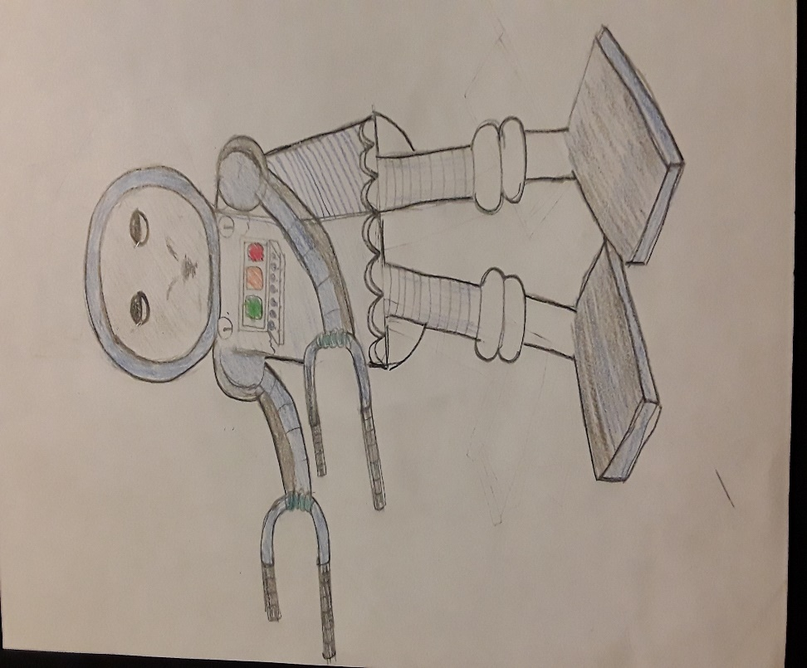The name that I chose my robot is to be called Picollo/x300. The reason why I named it Picollo is that the part “Pic” comes from pick-up and the term “ollo” comes from the term “load”. The term ”x300” means the capacity of the machine of how much the machine weighs. She is a medium sized dark and white coloured robot that is a programmed and connected through a computer for it is works of loading and unloading luggage, and big items that are normally loaded on the airplane. It can lift machines as heavy as 100 kg machines. There are cranes out there, but the robot is programmed and equipped to recognize and monitor the illegal substances and items those are banned on air travel. This way, it will save the trafficking of illegal substances used which it benefits the society. Some good things about this robot is that it reduces the loss of the luggage and theft when the airplane is to be boarded, meaning that no suitcases will be lost due to this machine. Picollo/x300 can even prevent the mishandling of the people’s values so whatever items are in the suitcase, and if something gets lost, the robot will take care of that.